**Lab 1**

**Select EC2 in the compute**

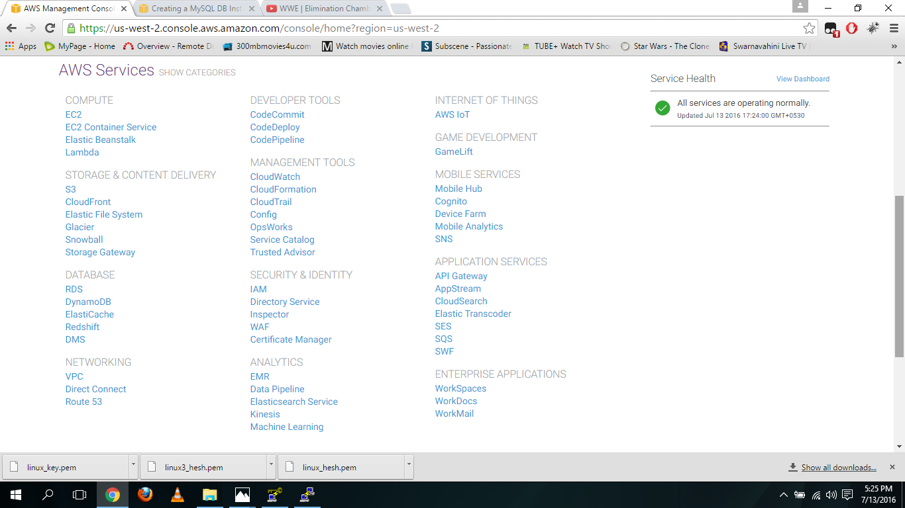

**Click the launch instance**

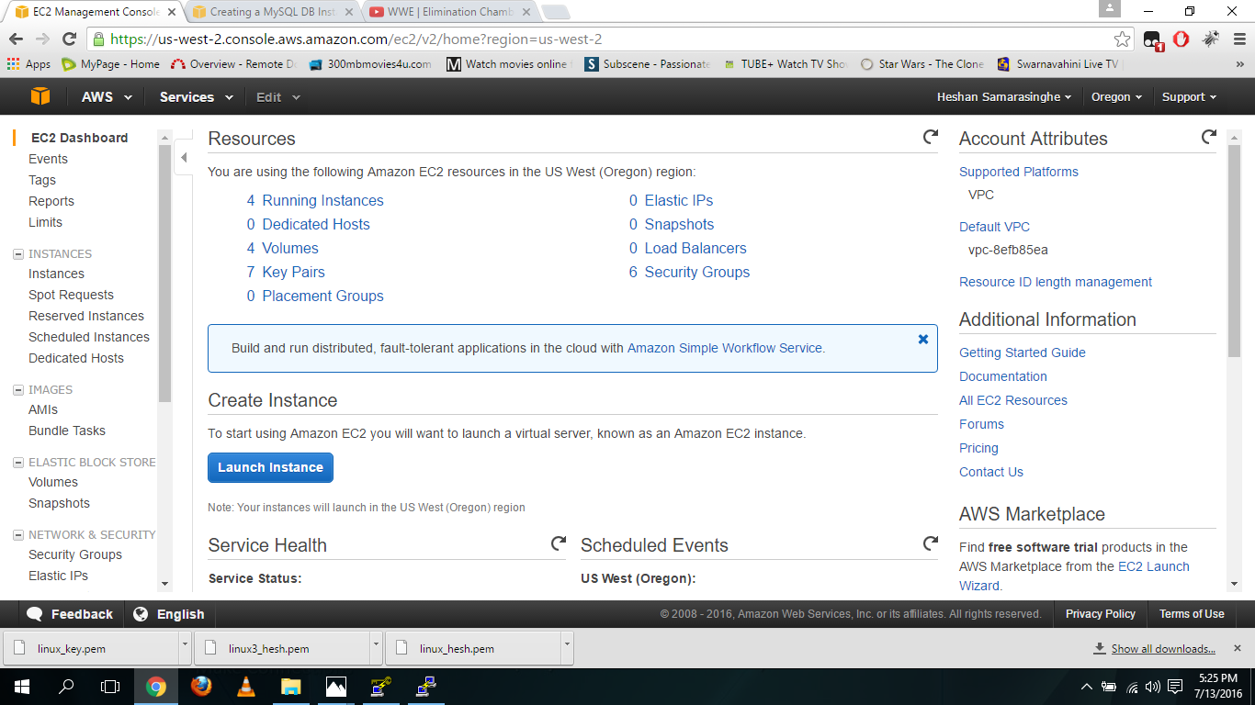

**Select windows server**

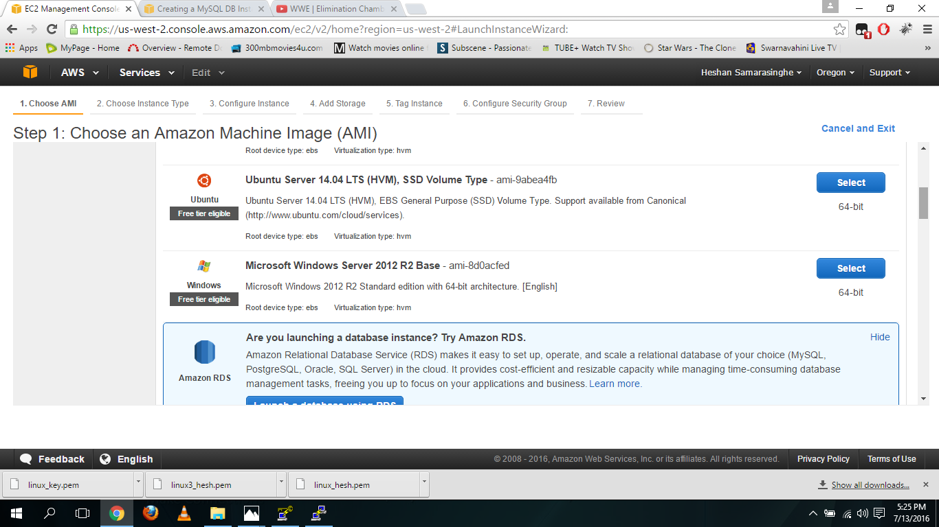

**Select t2.micro as the instance type**

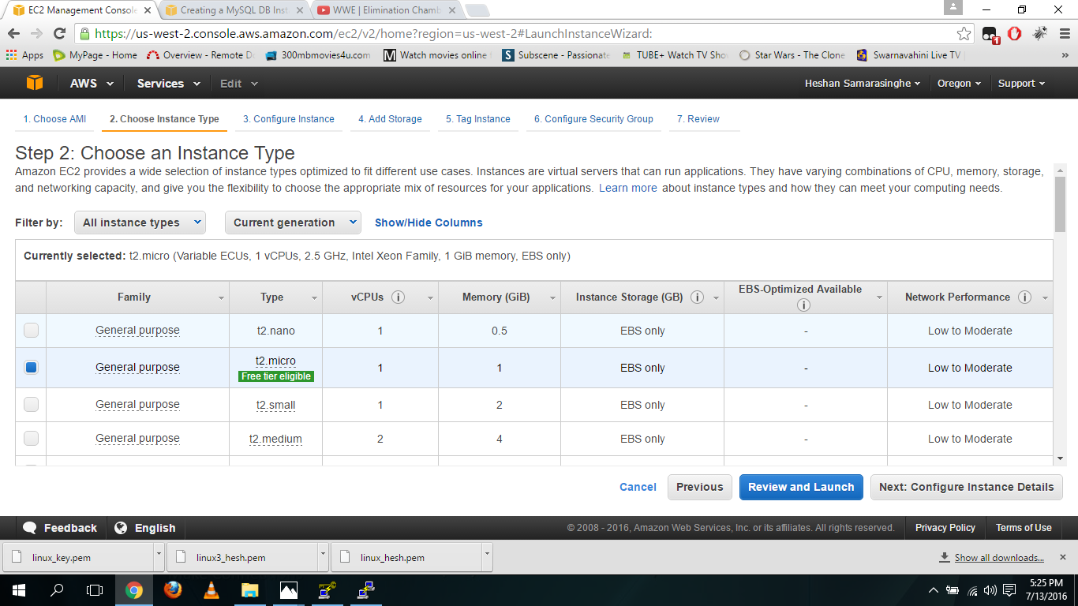

**Fill the configure instance**

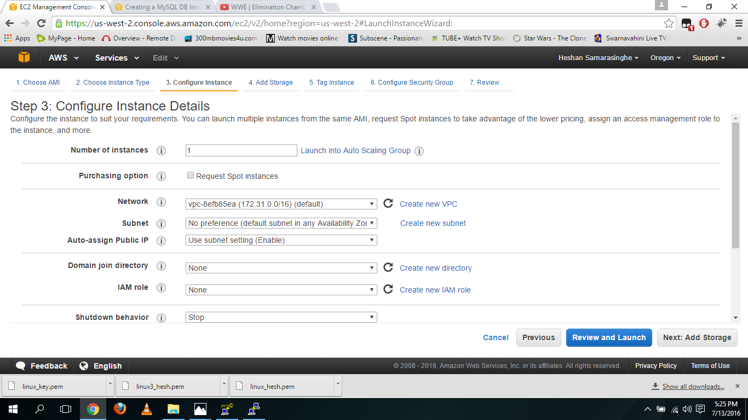

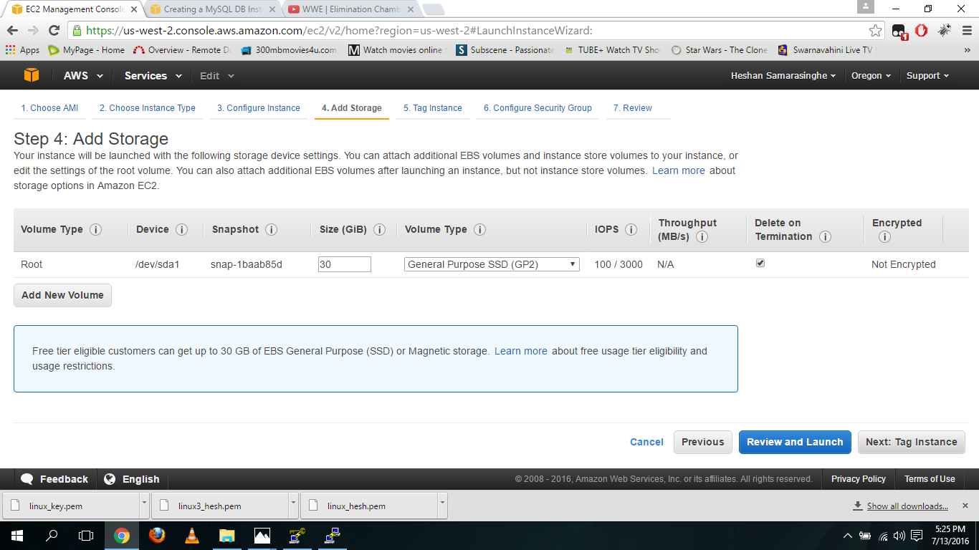**Fill add storage and click the review and launch**

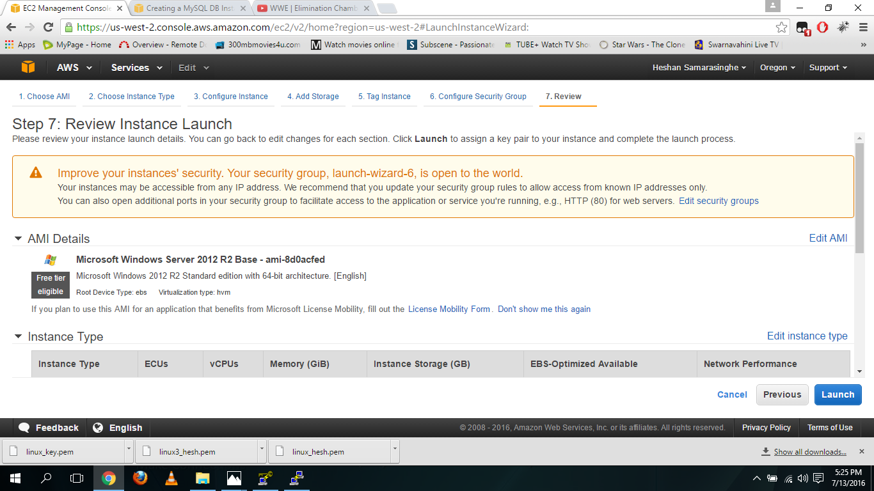**Click launch**

**Create a new key pair and download it and click launch instance**

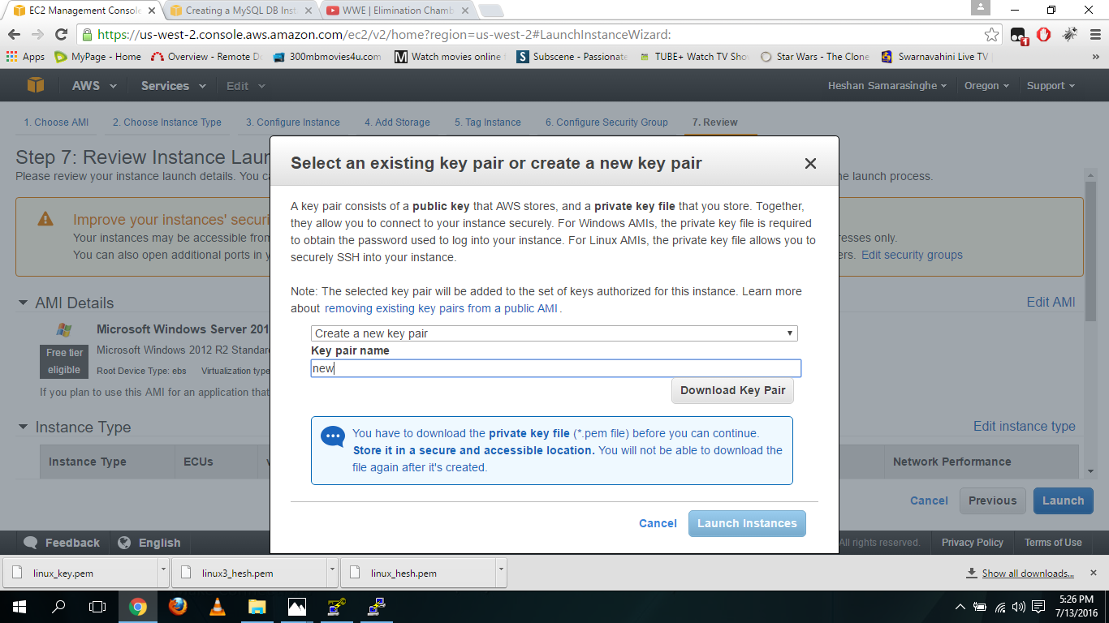

**Click view instance**

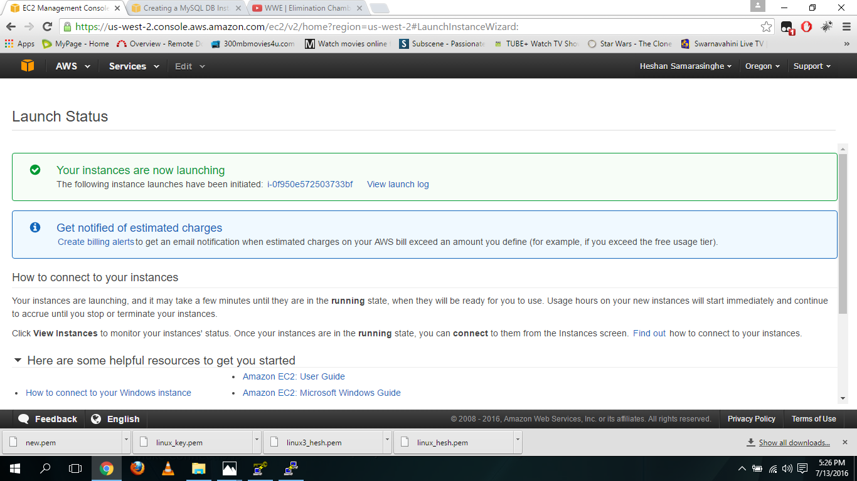

**Click connect**

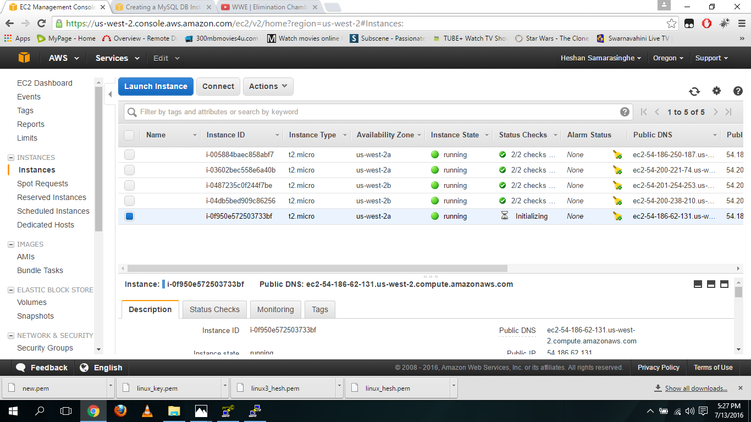

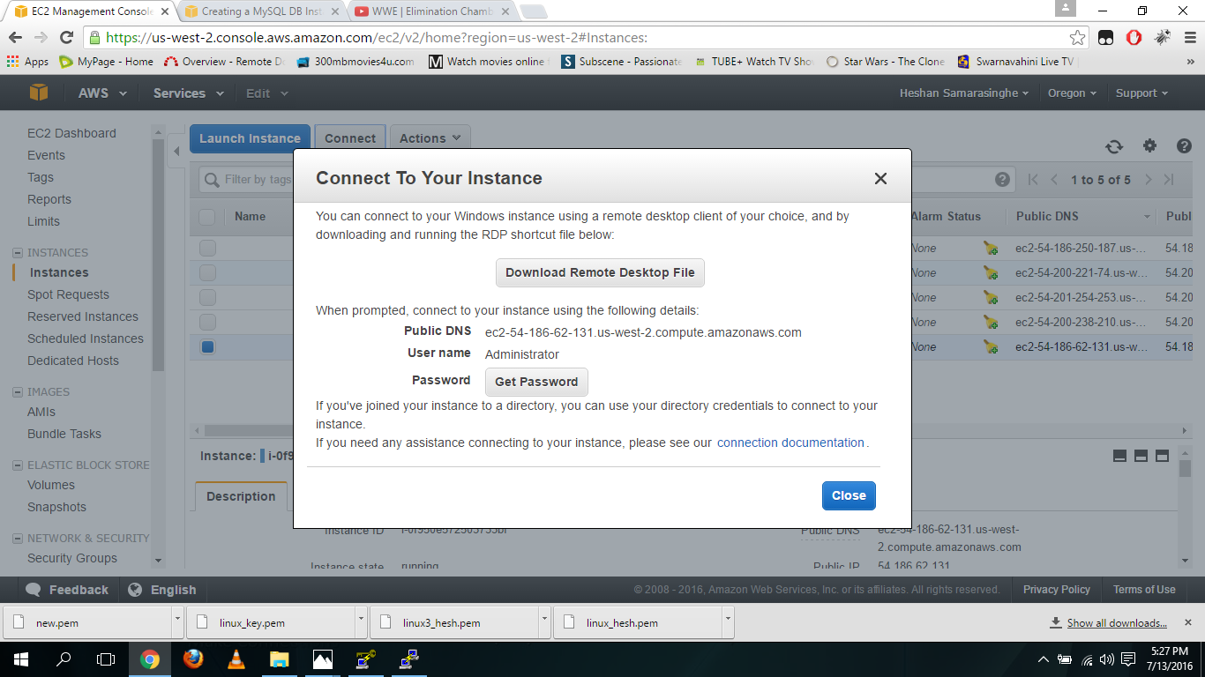**Click get password**

**Choose the earlier downloaded key**

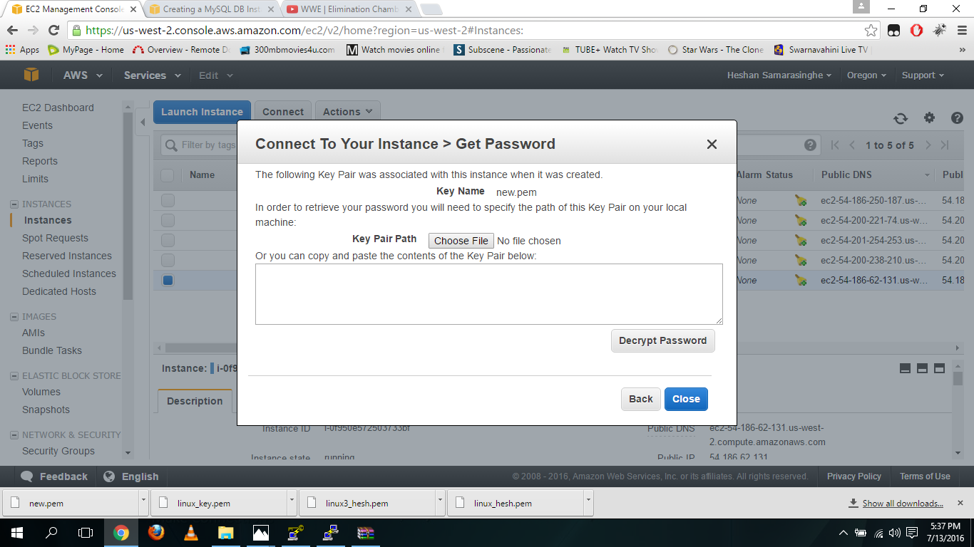

**Click decrypt the password button**

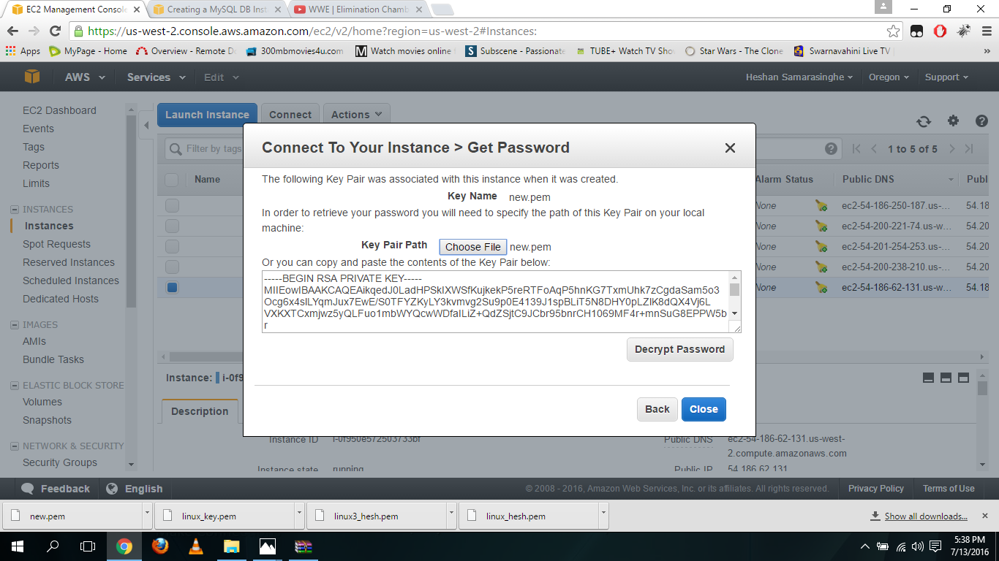

**Then password will decrypted and added**

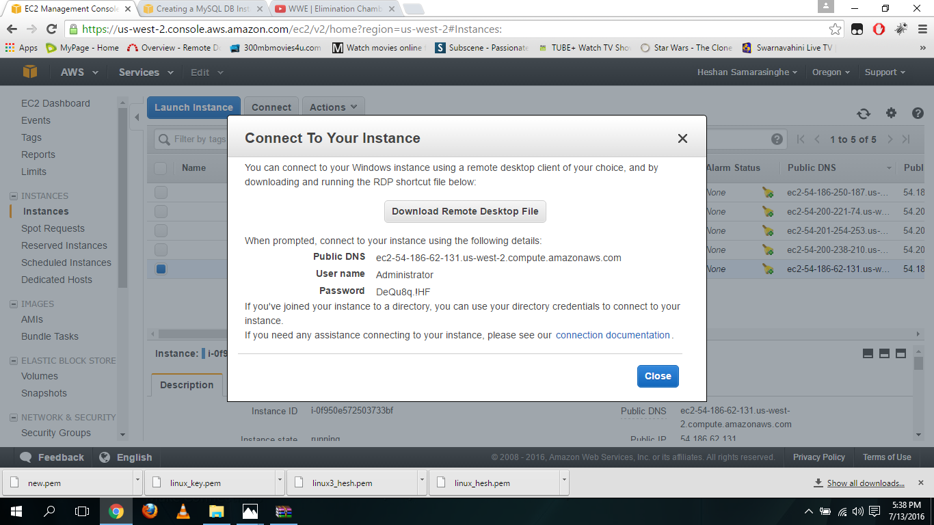

**Then open the remote desktop connection, add the public IP of the instance and click connect**

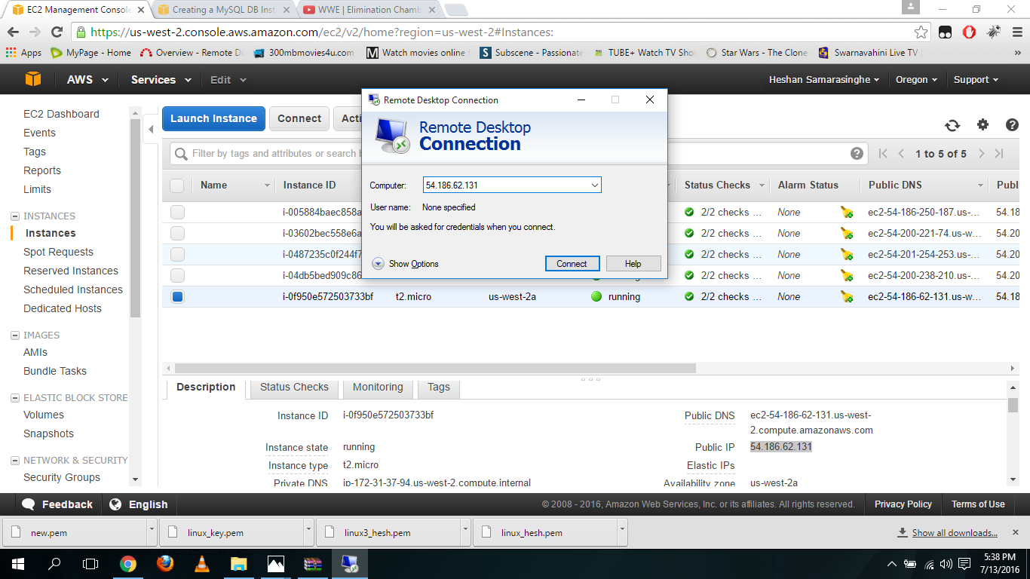

**Then window will pop fill its username and password from earlier details and select ok**

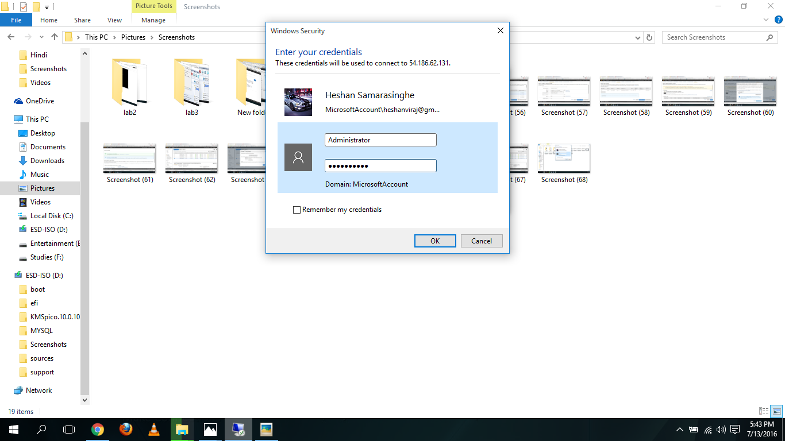

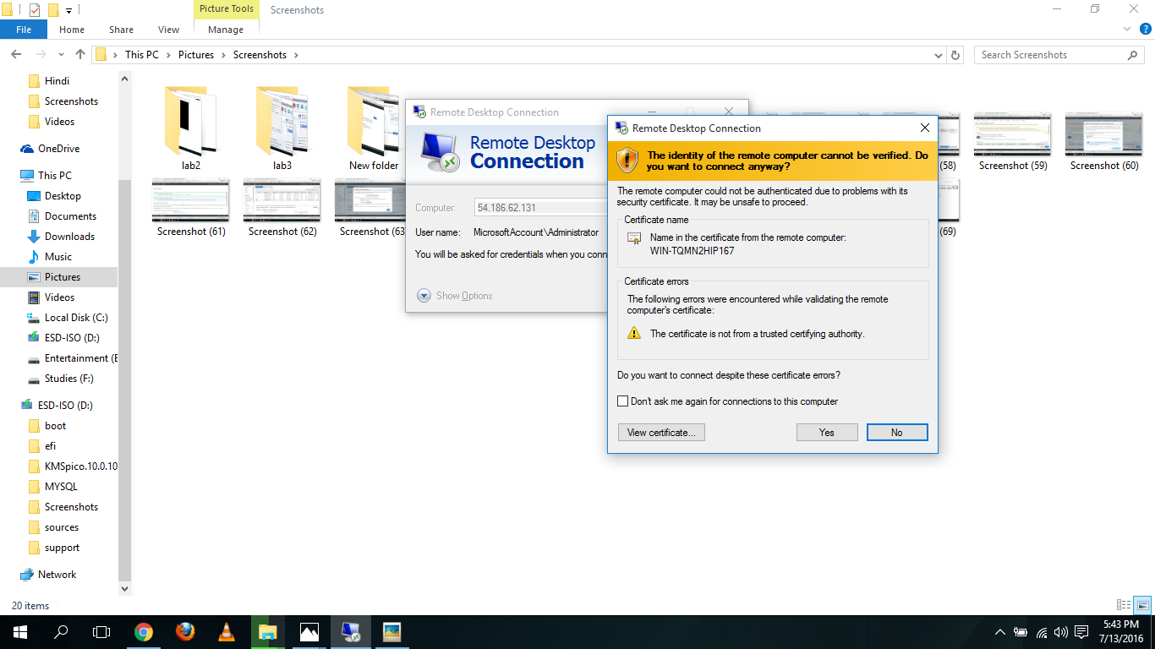**Then select no in the next pop up window**

**Then it will open the connected windows server**

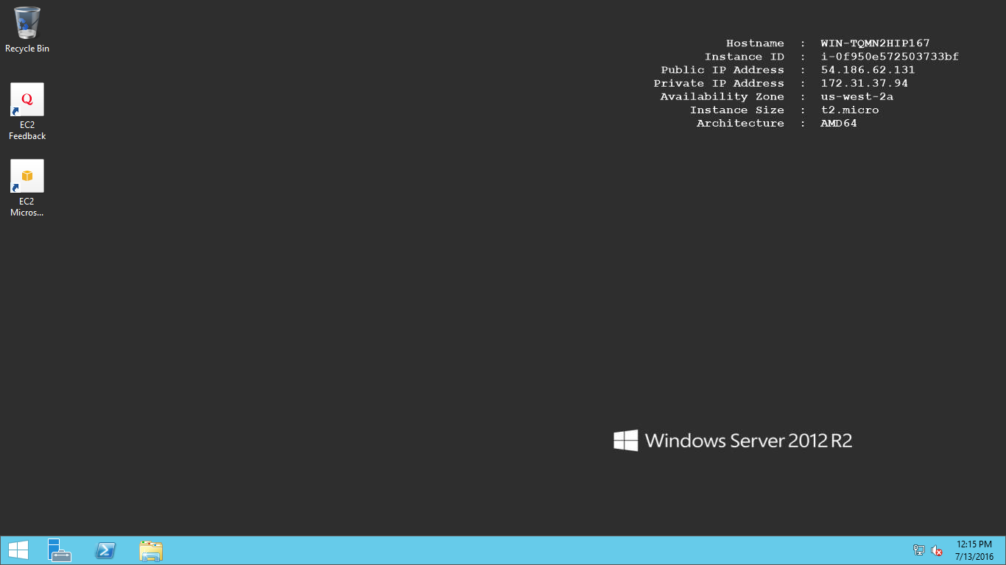

**Lab 2**

**Select EC2**

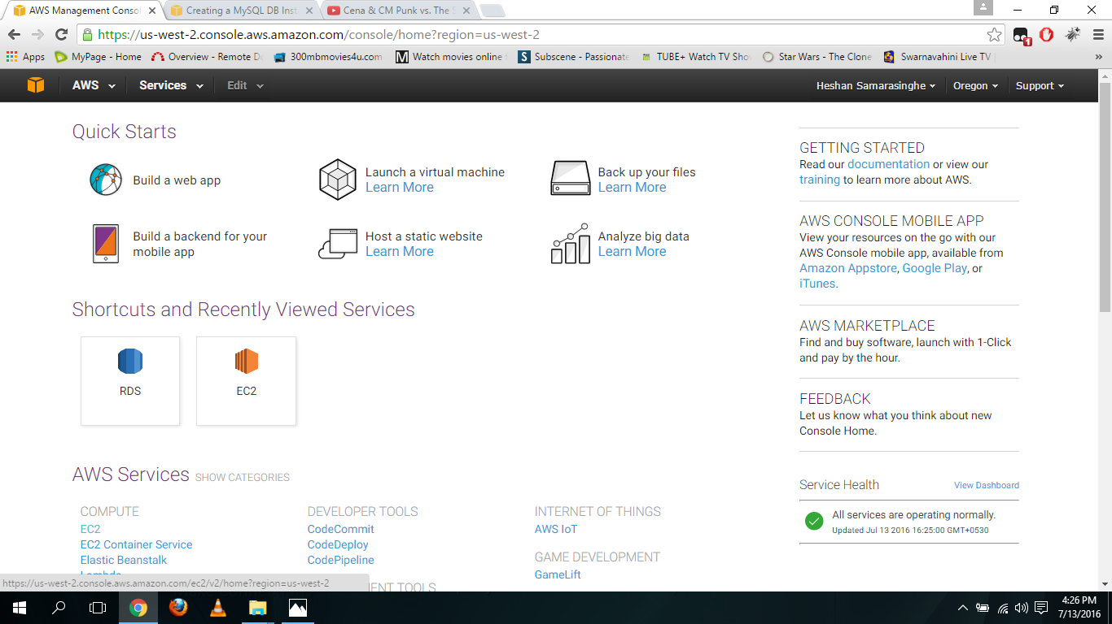

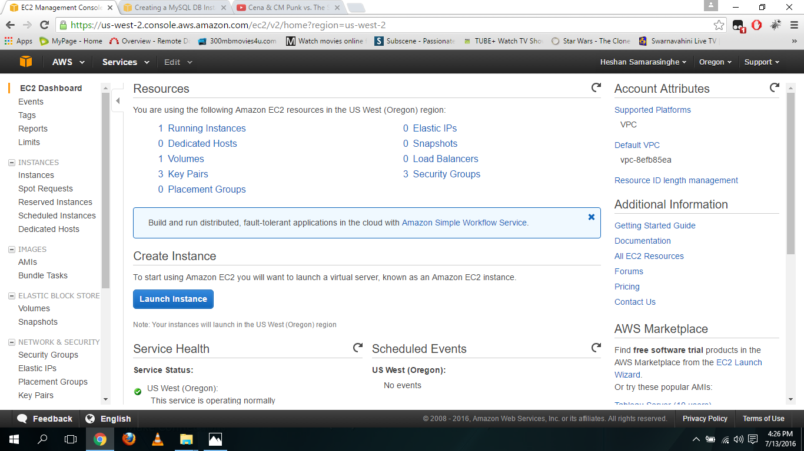**Click the launch instance**

**Select amazon Linux AMI**

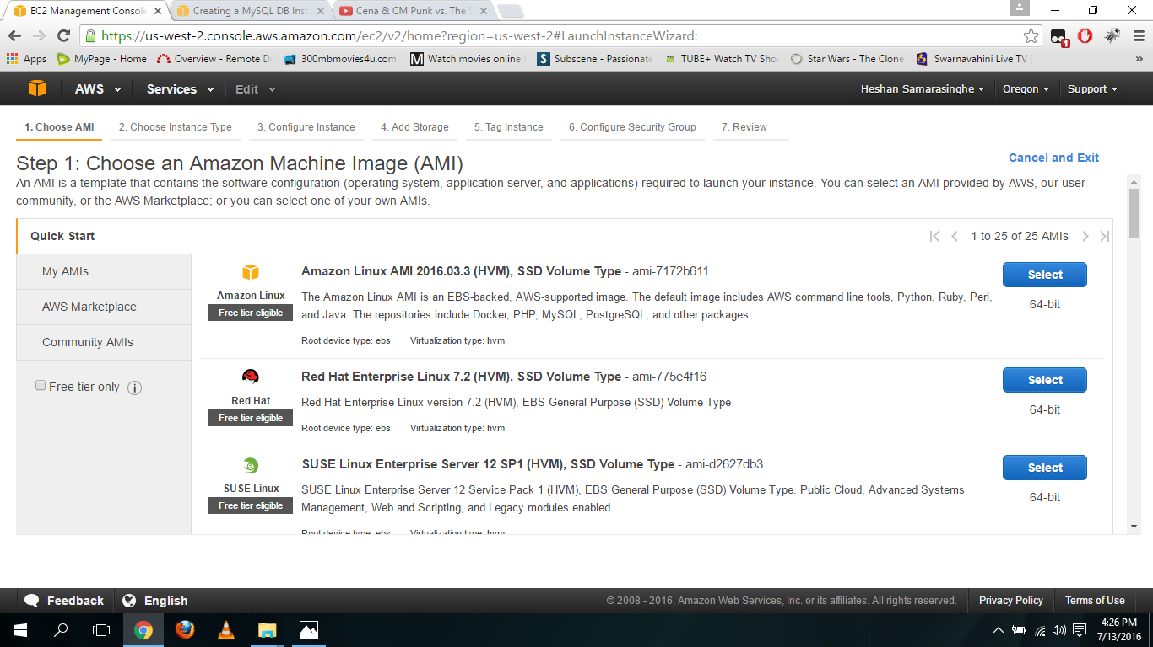

**Select t2.micro as the instance type**

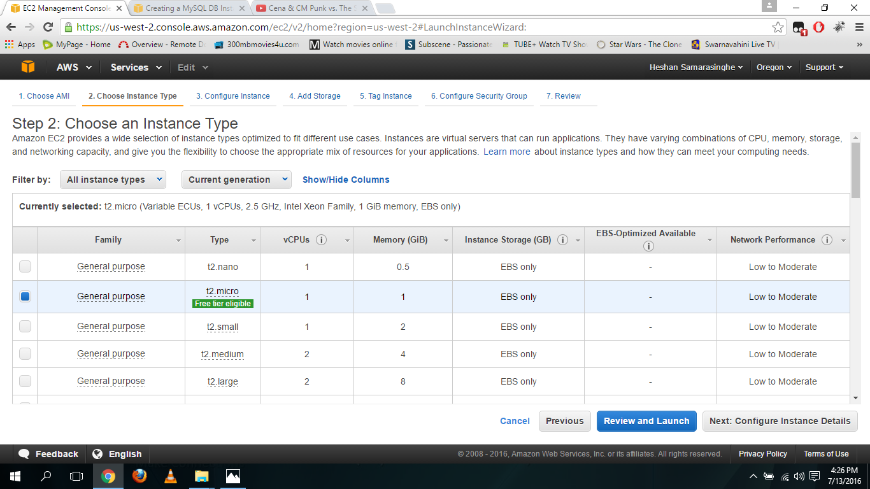

**Fill the configure instance**

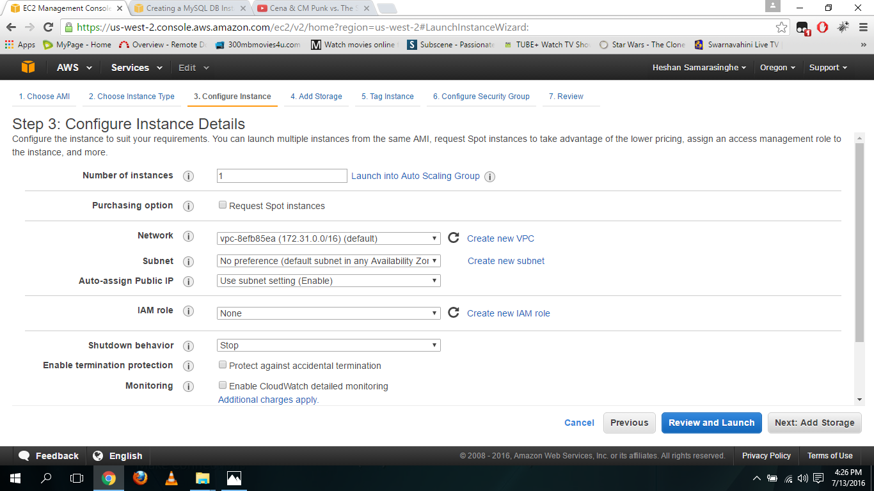

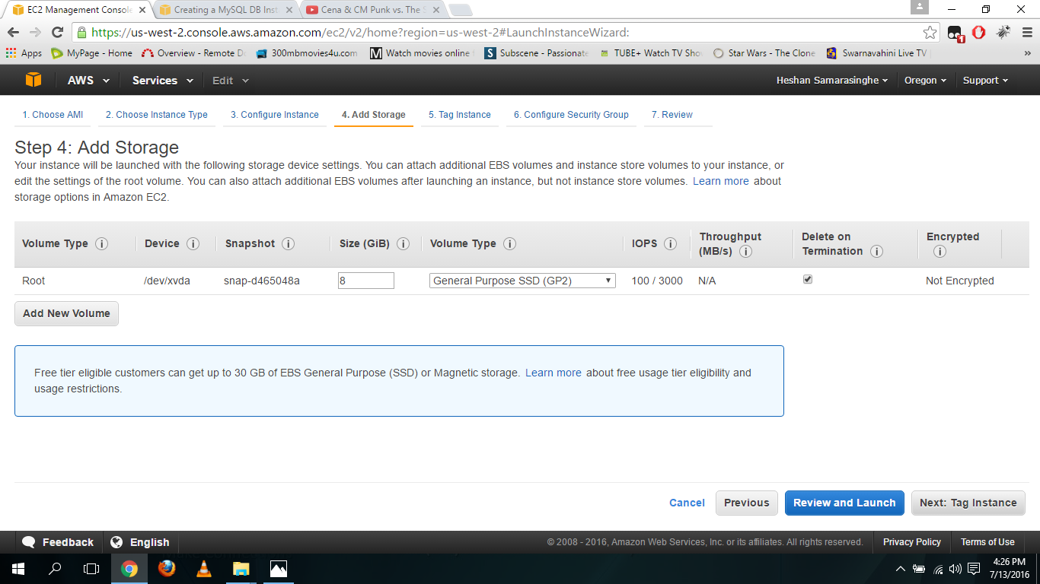**Fill add storage and click review and launch**

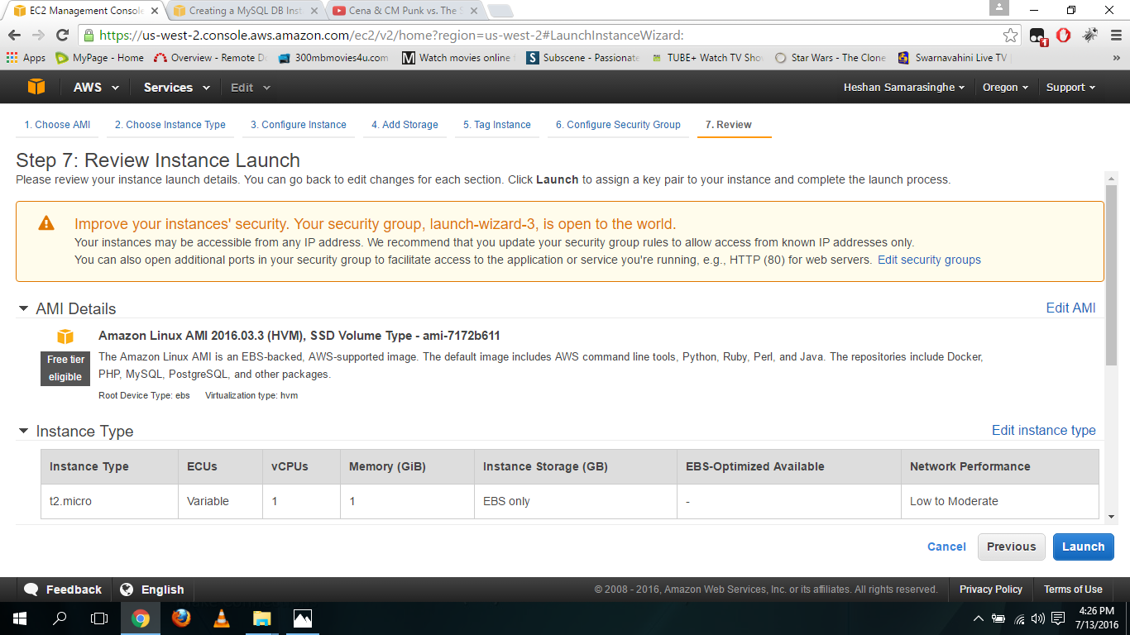**Click launch**

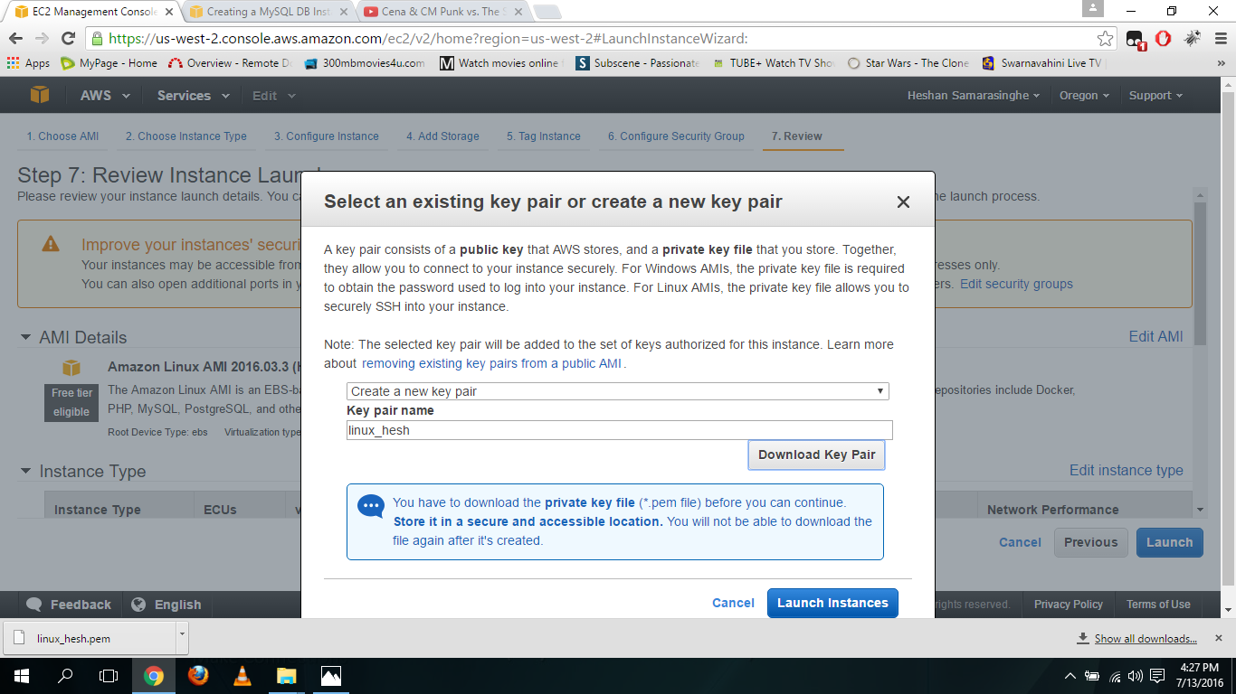**Create a new key and download it and click launch instance**

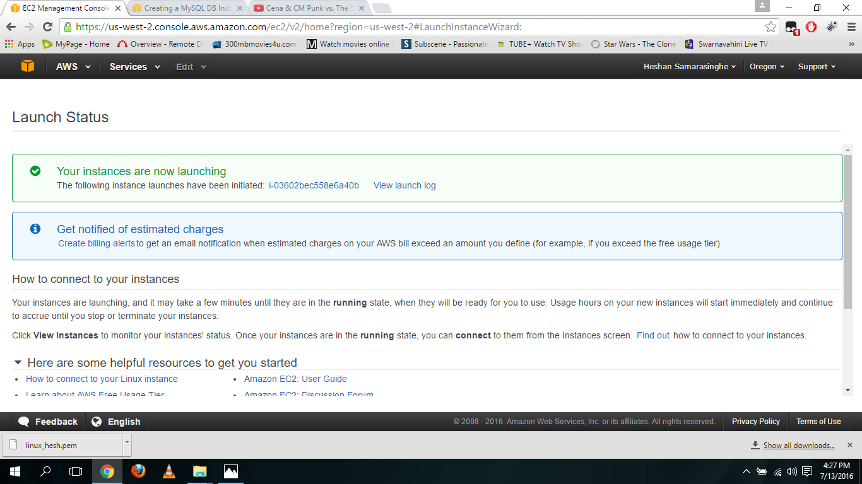**Click view instance**

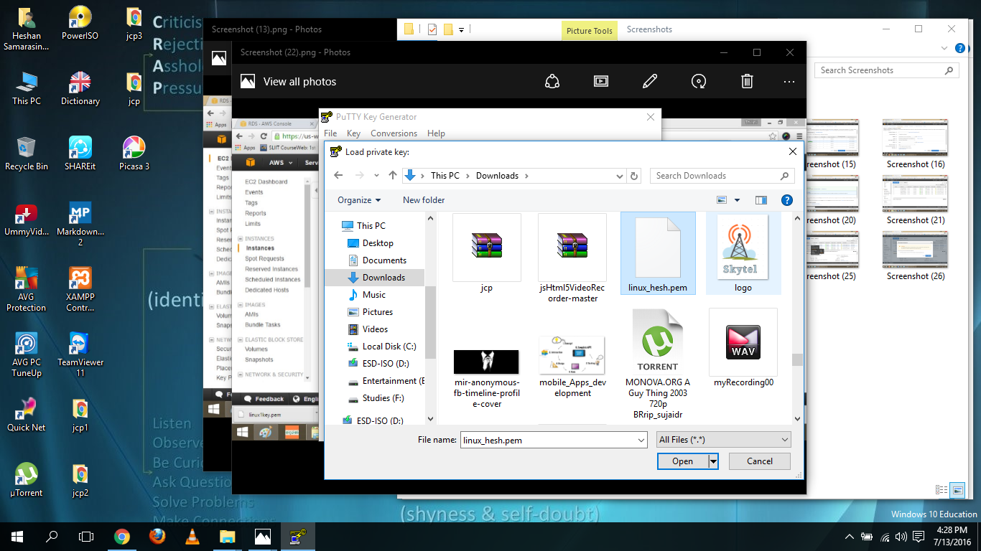**Open the PUTTY Generator and add the key that earlier downloaded one to it and click save private key and save it**

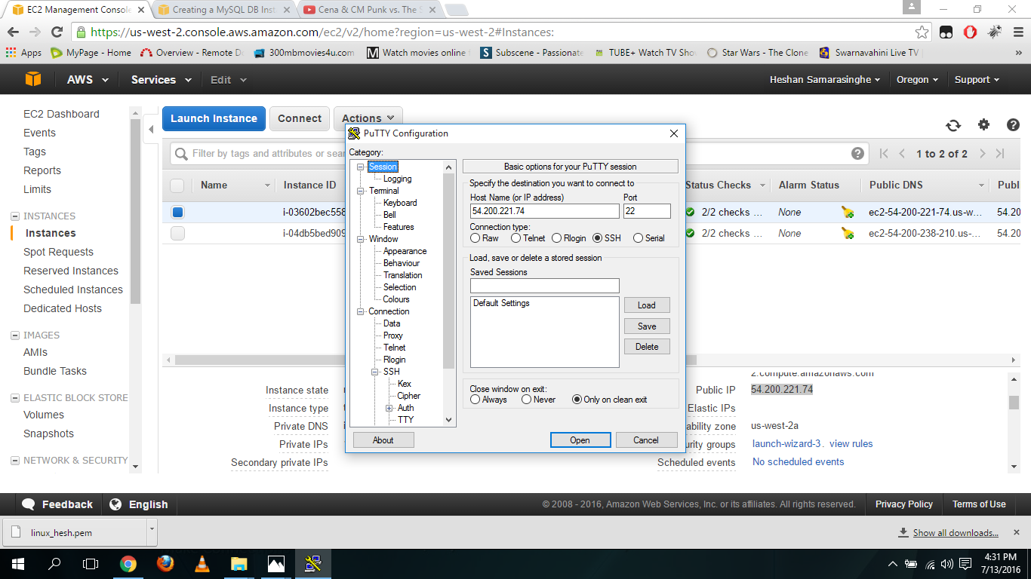**Then open the PUTTY and add the public IP as the host name**

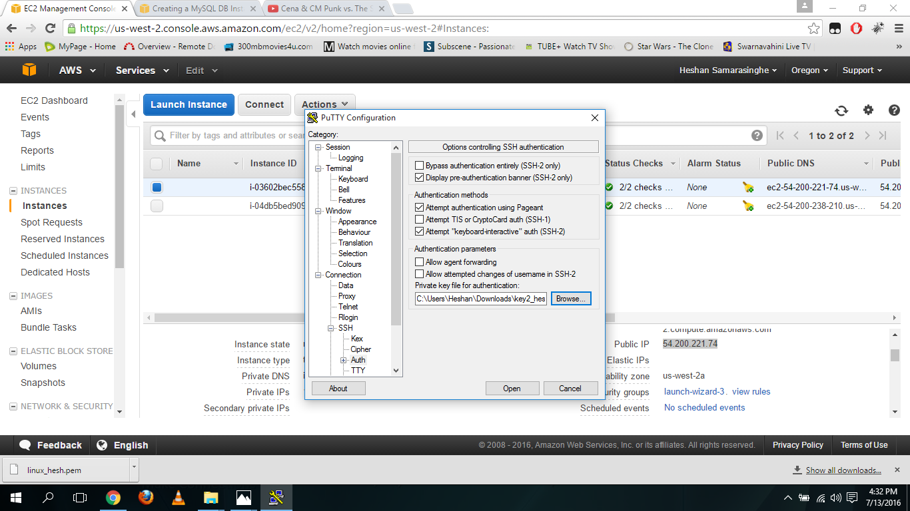**Then go to SSH AUTH in putty and select that private key we save earlier and click open**

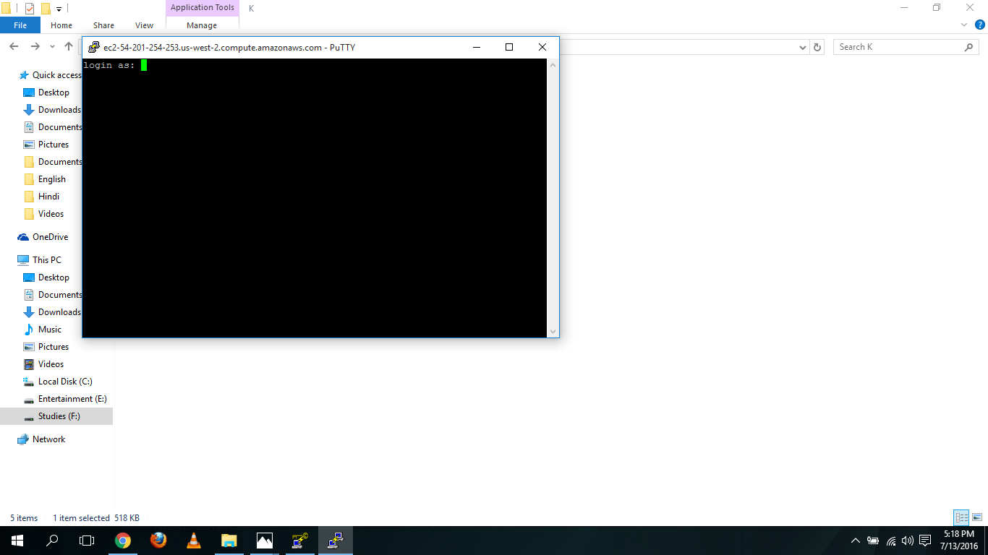**Then command prompt window will open**

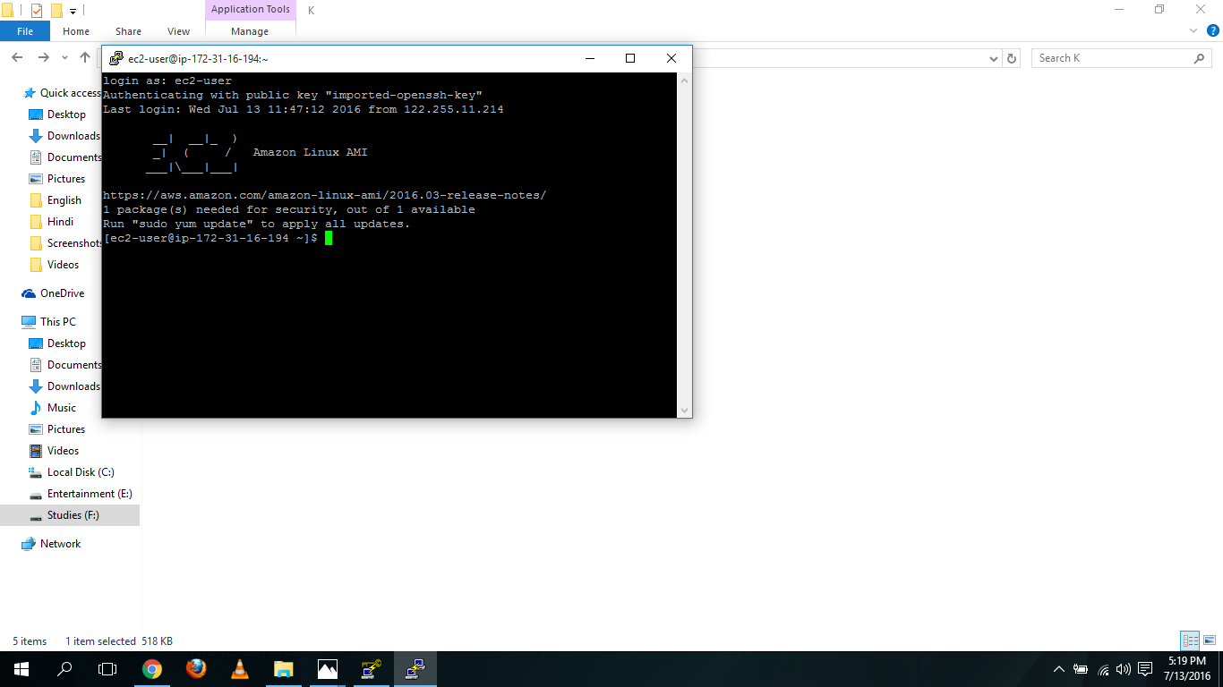**In it type “ec2-user” to the login as and press enter**

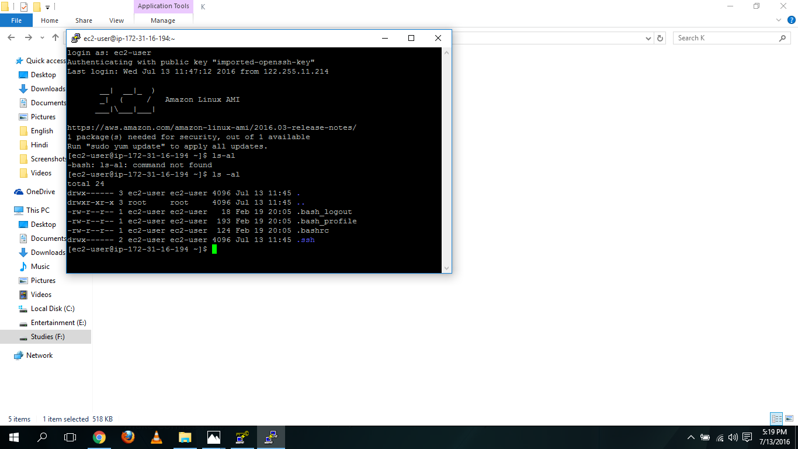**Then type “ls –al” in it**

**Lab 3**

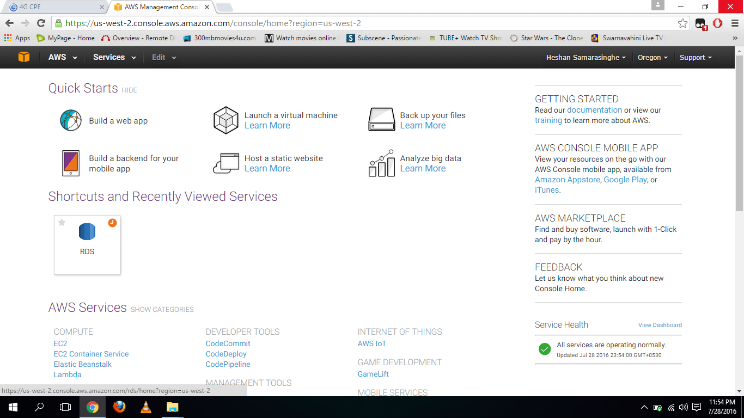**Select RDS**

**Select instance in RDS Dashboard and click launch DB instance**

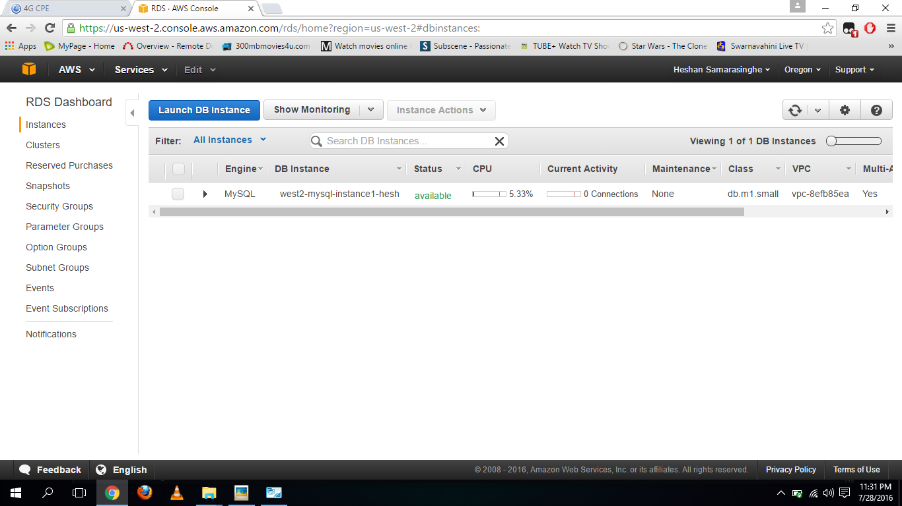

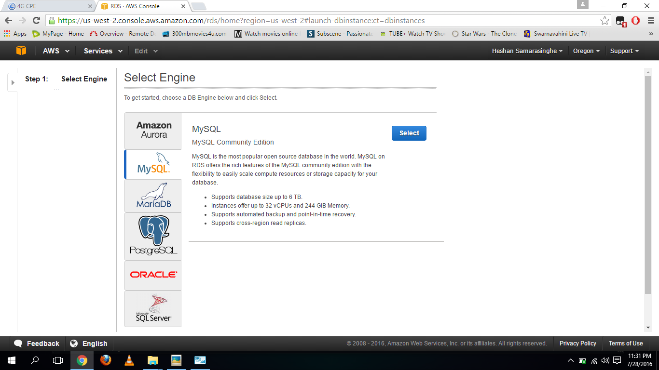**Select My SQL and click Select button**

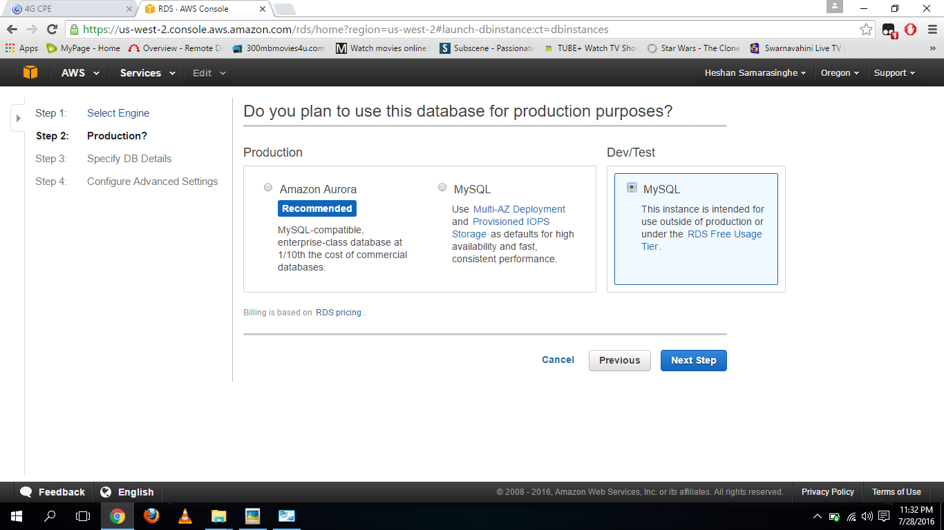**Select DEV/Test My SQL and click Next Step**

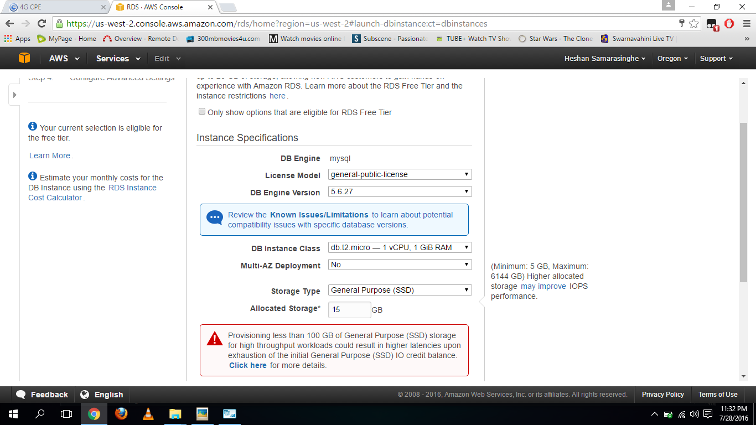**Fill the Instance Specifications part**

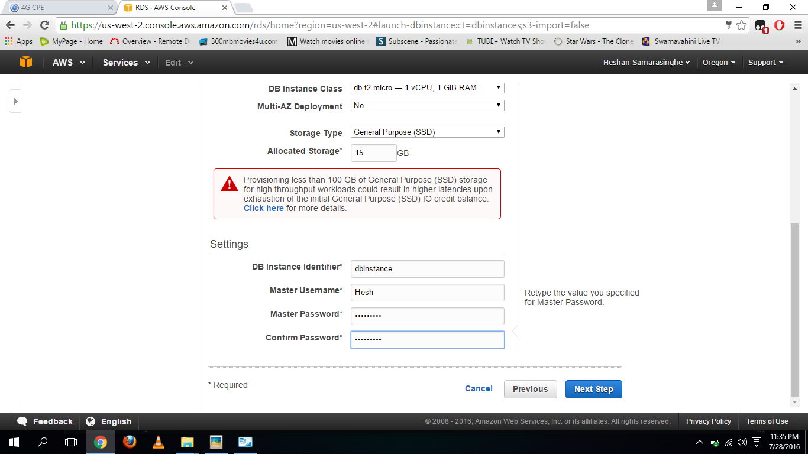**Fill Settings part and click next step**

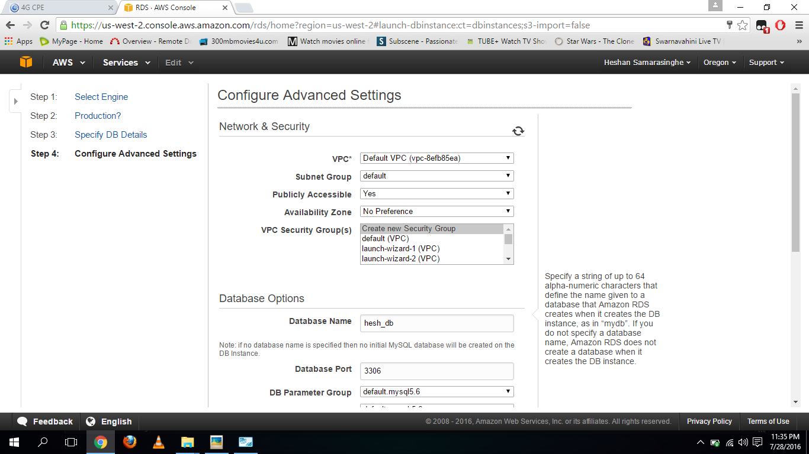**Fill Network and Security part**

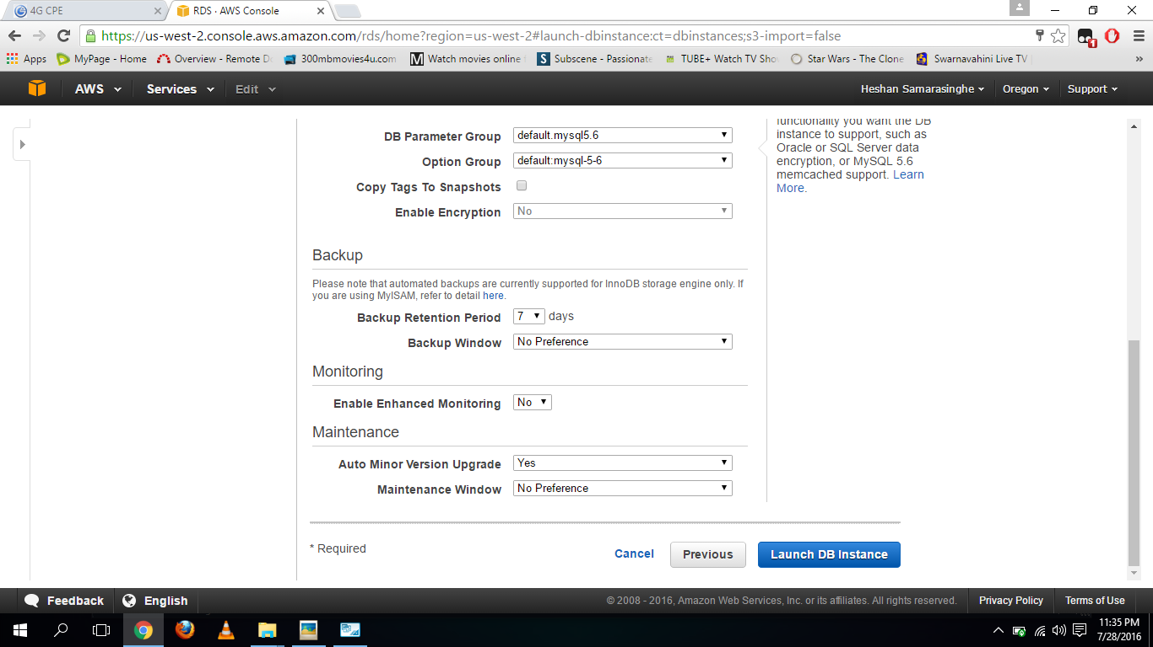**Fill Database Options part and Backup part and Monitoring part and click launch DB instance**

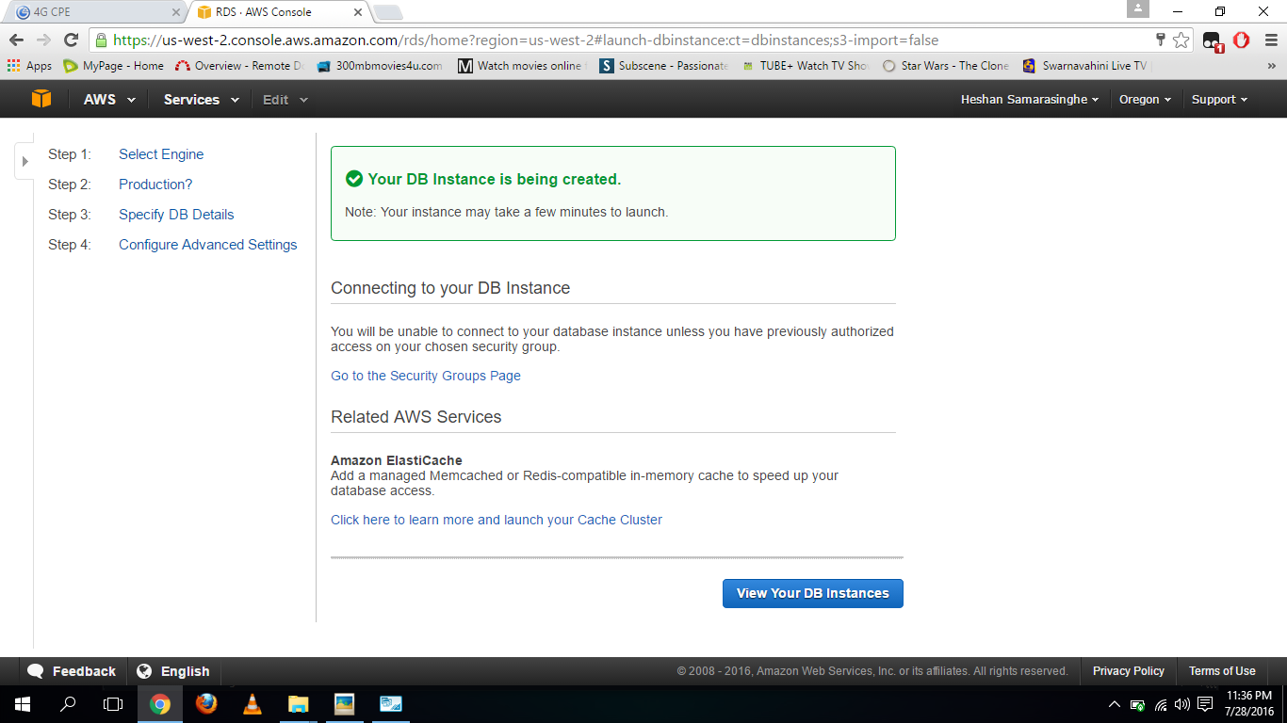**Click view your DB instances**

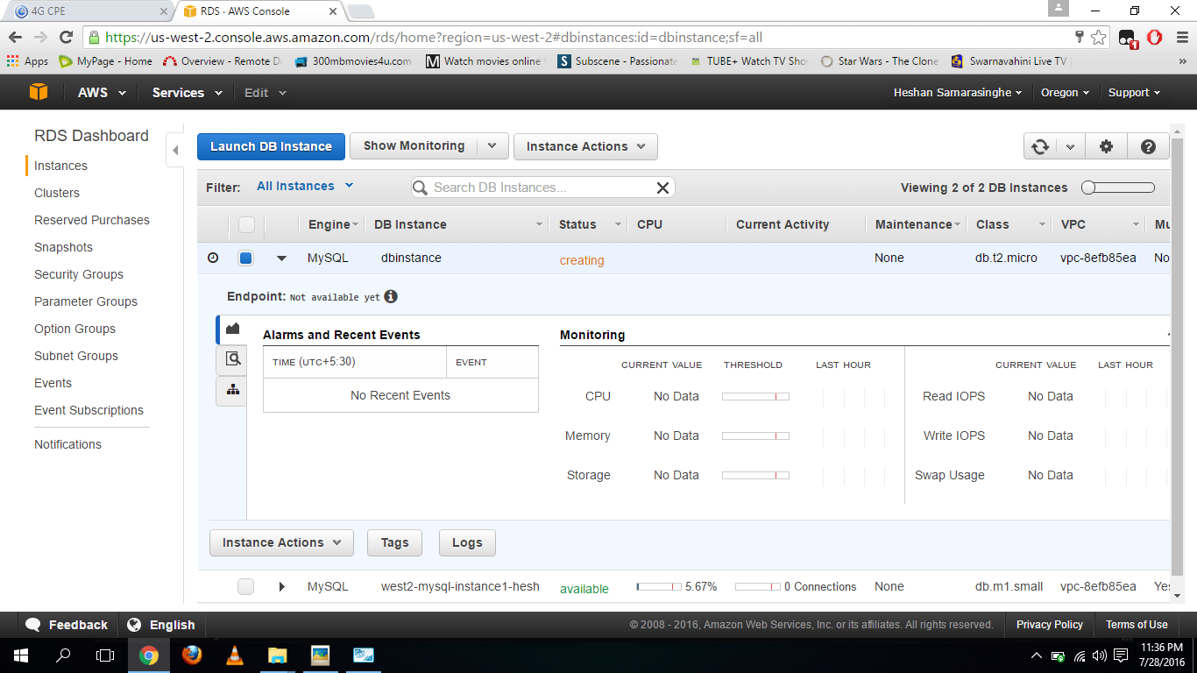**DB instance in creating stage**

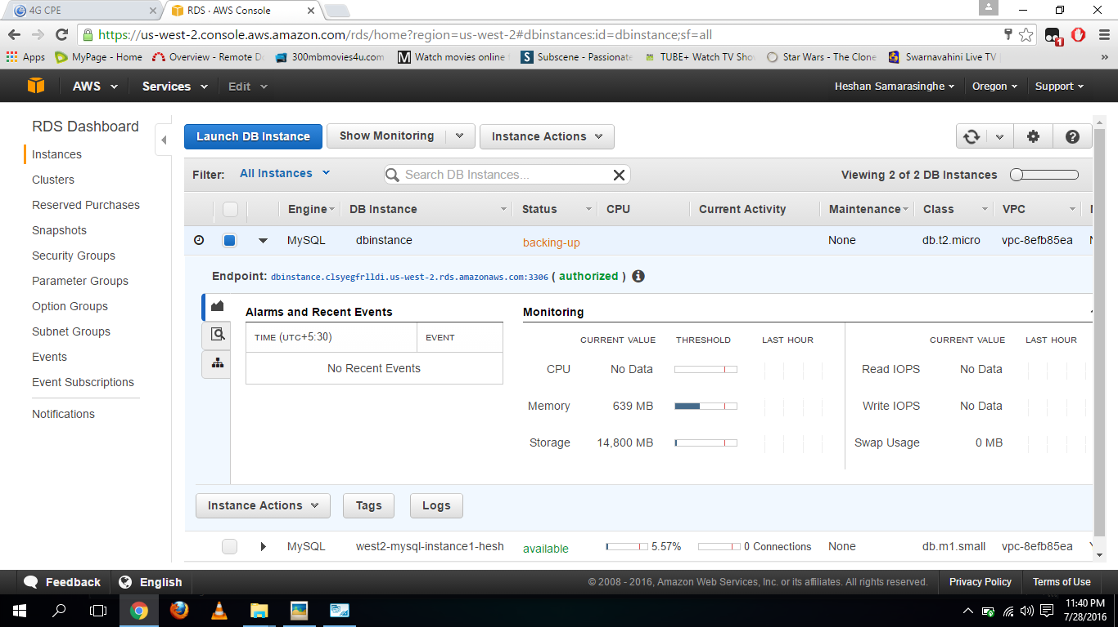**DB Instance in backing-up stage**

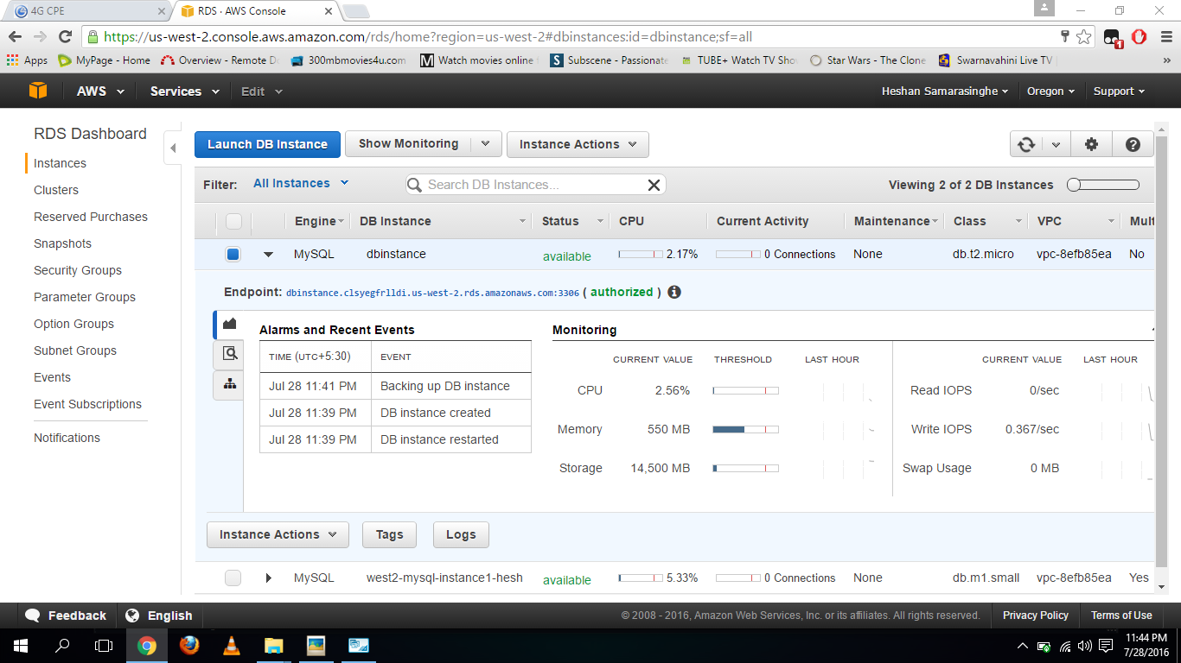**DB instance in available stage**

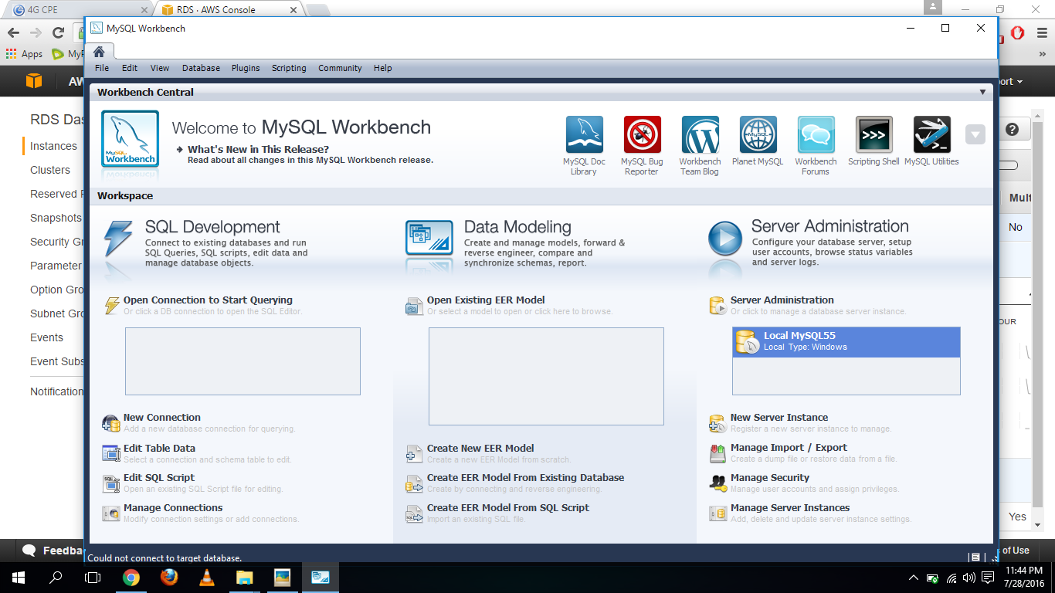**Open My SQL workbench**

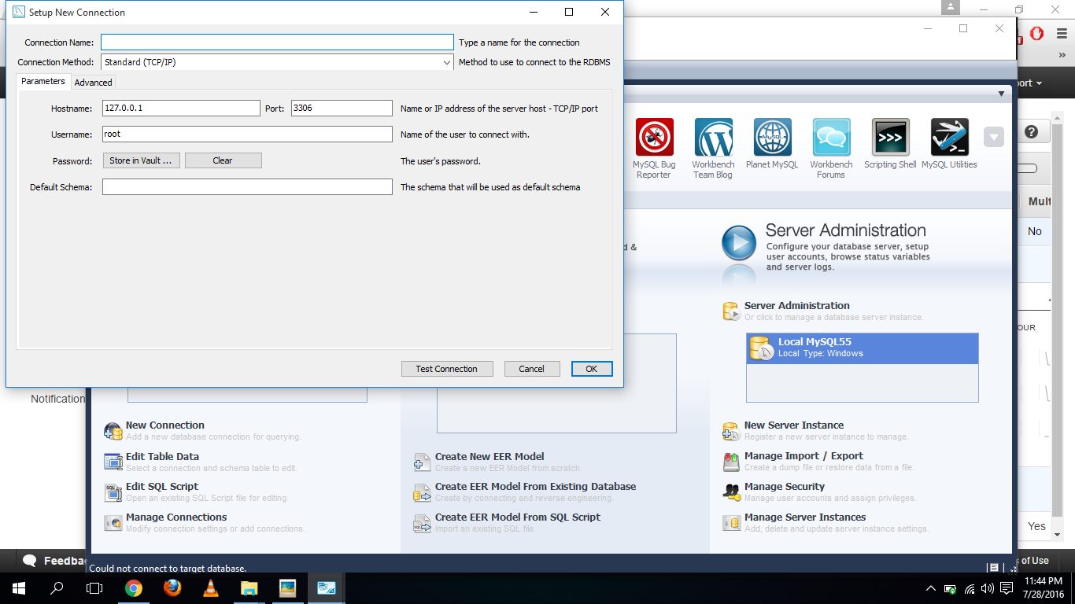**Click New Connection**

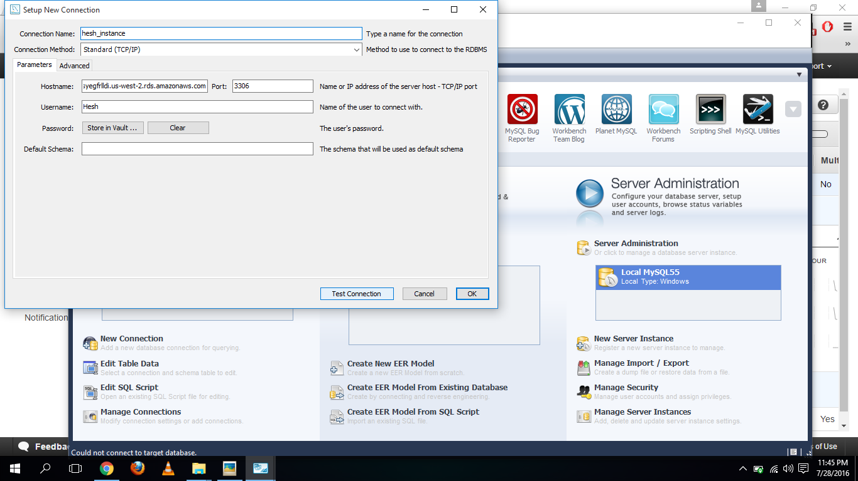**Fill Setup New Connection blanks and click Ok**

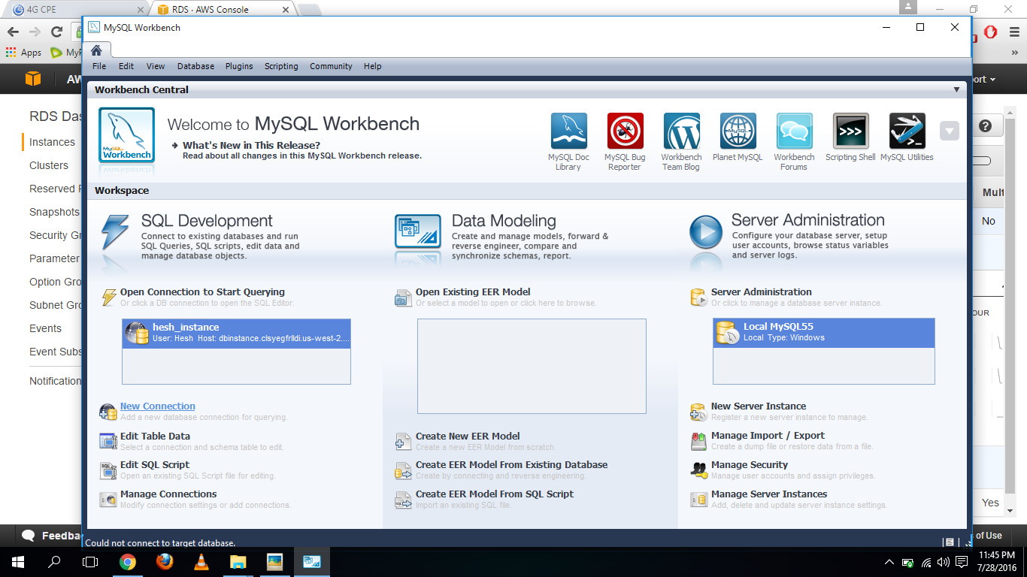**Then Open the created Connection**

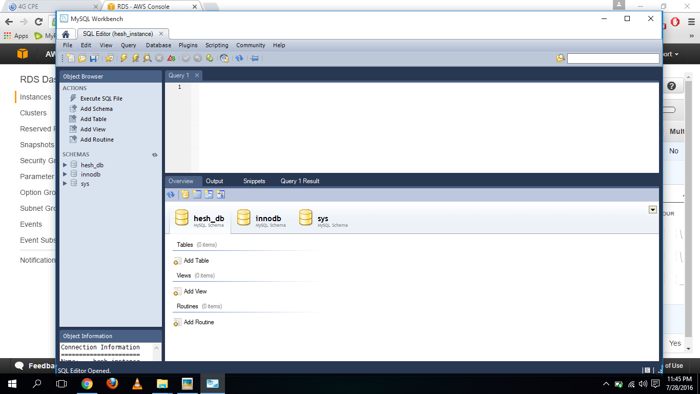**The Connection Opened**

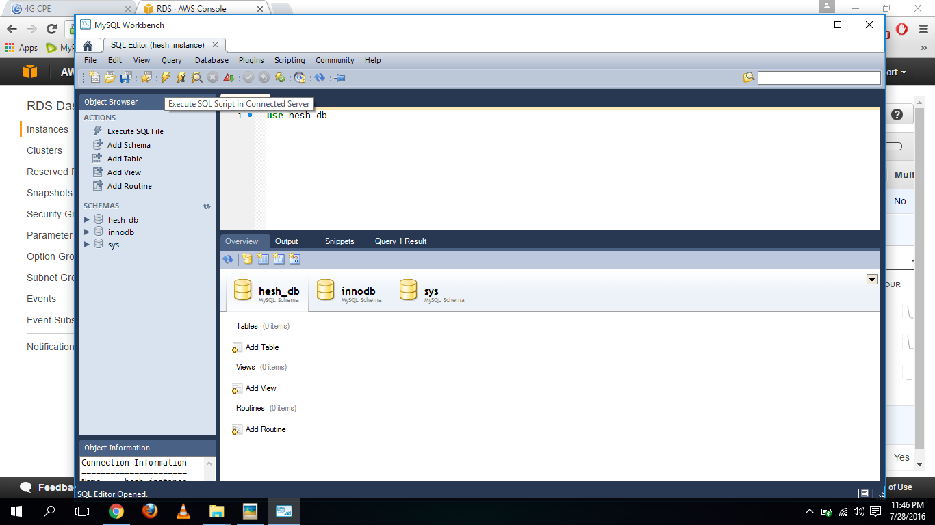**Use earlier created our Database**

**Create a table**

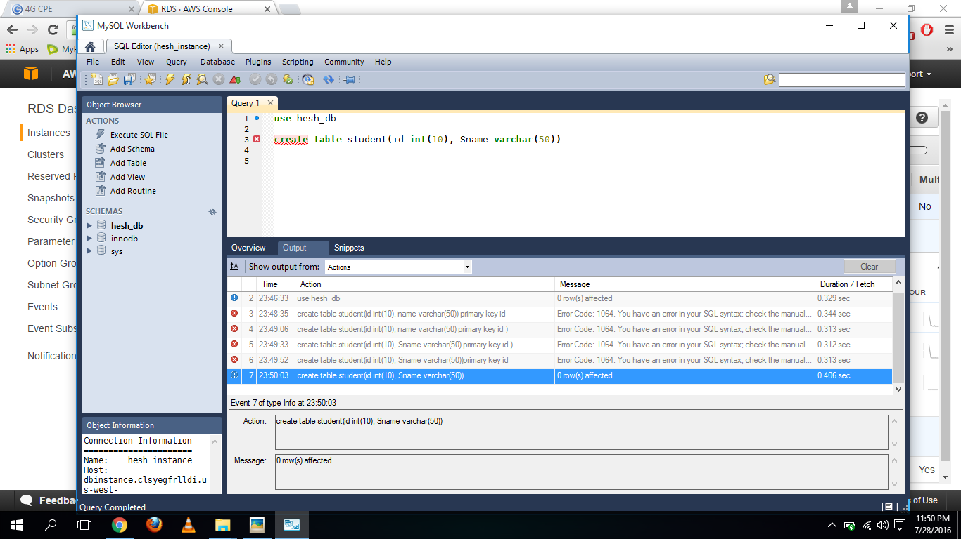

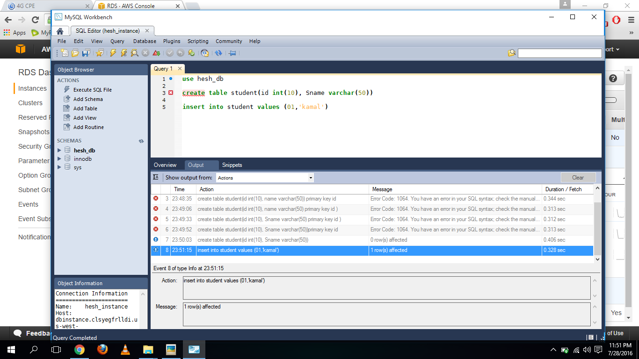**Insert values to the table**

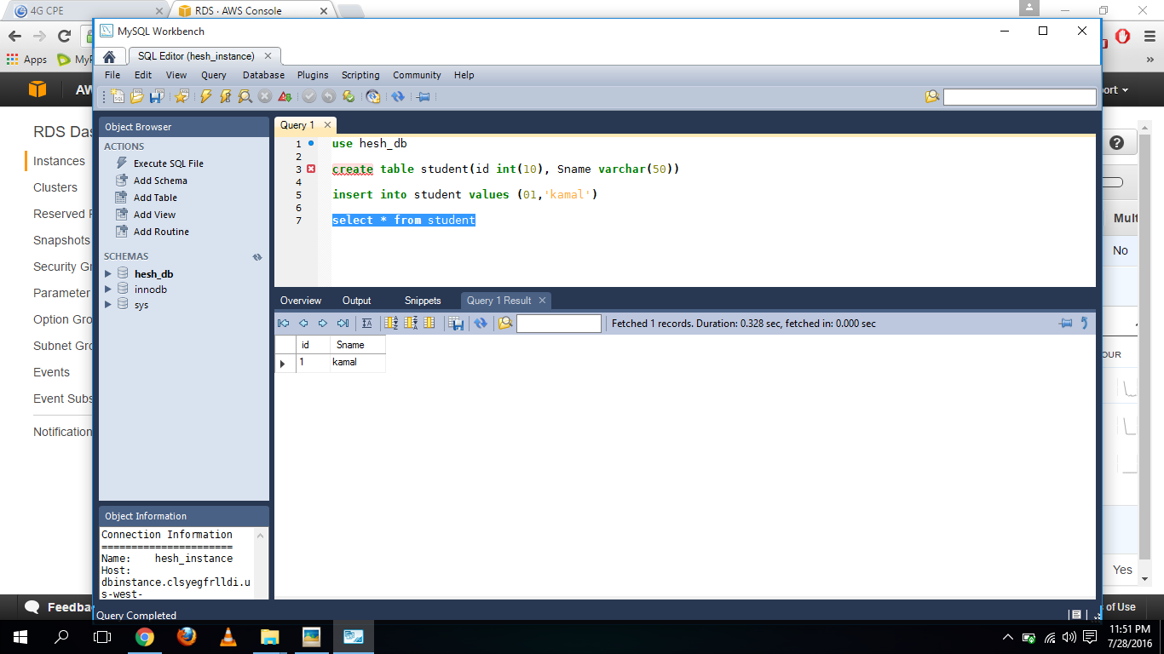**Get a output**